PIZZA SALES SQL QUERIES
KPI:
1. Total Revenue:
SELECT SUM(total_price) AS Total_Revenue FROM pizza_sales;
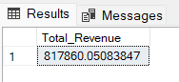
2. Average Order Value
SELECT (SUM(total_price) / COUNT(DISTINCT order_id)) AS Avg_order_Value FROM pizza_sales
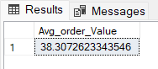
3. Total Pizzas Sold
SELECT SUM(quantity) AS Total_pizza_sold FROM pizza_sales
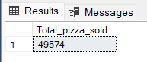
4. Total Orders
SELECT COUNT(DISTINCT order_id) AS Total_Orders FROM pizza_sales
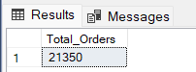
5. Average Pizzas Per Order
SELECT CAST(CAST(SUM(quantity) AS DECIMAL(10,2)) /
CAST(COUNT(DISTINCT order_id) AS DECIMAL(10,2)) AS DECIMAL(10,2))
AS Avg_Pizzas_per_order
FROM pizza_sales
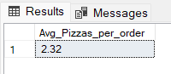
Hourly Trend for Total Pizzas Sold:
SELECT DATEPART(HOUR, order_time) as order_hours, SUM(quantity) as total_pizzas_sold
from pizza_sales
group by DATEPART(HOUR, order_time)
order by DATEPART(HOUR, order_time)
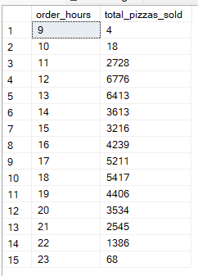
Weekly Trend for Orders:
SELECT
DATEPART(ISO_WEEK, order_date) AS WeekNumber,
YEAR(order_date) AS Year,
COUNT(DISTINCT order_id) AS Total_orders
FROM
pizza_sales
GROUP BY
DATEPART(ISO_WEEK, order_date),
YEAR(order_date)
ORDER BY
Year, WeekNumber;
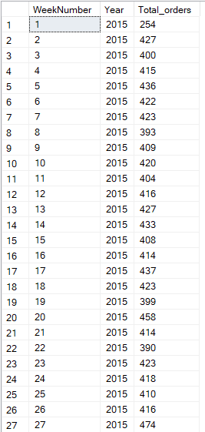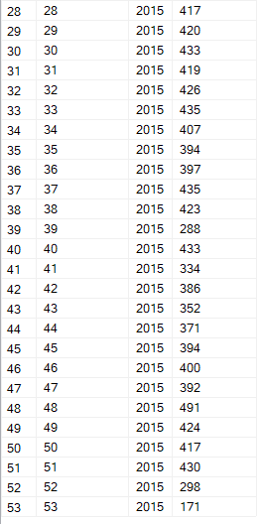
% of Sales by Pizza Category:
SELECT pizza_category, CAST(SUM(total_price) AS DECIMAL(10,2)) as total_revenue,
CAST(SUM(total_price) * 100 / (SELECT SUM(total_price) from pizza_sales) AS DECIMAL(10,2)) AS PCT
FROM pizza_sales
GROUP BY pizza_category
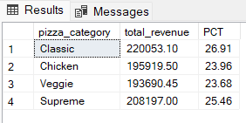
% of Sales by Pizza Size:
SELECT pizza_size, CAST(SUM(total_price) AS DECIMAL(10,2)) as total_revenue,
CAST(SUM(total_price) * 100 / (SELECT SUM(total_price) from pizza_sales) AS DECIMAL(10,2)) AS PCT
FROM pizza_sales
GROUP BY pizza_size
ORDER BY pizza_size
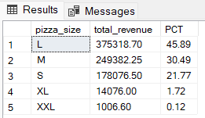
Total Pizzas Sold by Pizza Category:
SELECT pizza_category, SUM(quantity) as Total_Quantity_Sold
FROM pizza_sales
WHERE MONTH(order_date) = 2
GROUP BY pizza_category
ORDER BY Total_Quantity_Sold DESC
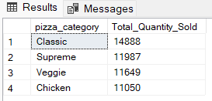
Top 5 Pizzas by Revenue:
SELECT Top 5 pizza_name, SUM(total_price) AS Total_Revenue
FROM pizza_sales
GROUP BY pizza_name
ORDER BY Total_Revenue DESC
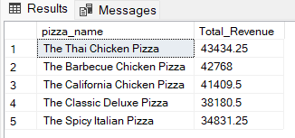
Bottom 5 Pizzas by Revenue:
SELECT Top 5 pizza_name, SUM(total_price) AS Total_Revenue
FROM pizza_sales
GROUP BY pizza_name
ORDER BY Total_Revenue ASC
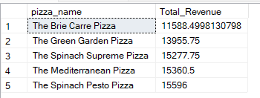
Top 5 Pizzas by Quantity:
SELECT Top 5 pizza_name, SUM(quantity) AS Total_Pizza_Sold
FROM pizza_sales
GROUP BY pizza_name
ORDER BY Total_Pizza_Sold DESC
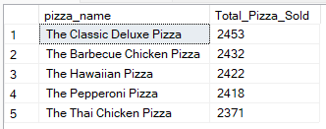
Bottom 5 Pizzas by Quantity:
SELECT TOP 5 pizza_name, SUM(quantity) AS Total_Pizza_Sold
FROM pizza_sales
GROUP BY pizza_name
ORDER BY Total_Pizza_Sold ASC
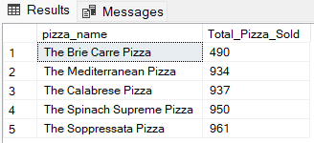
Top 5 Pizzas by Total Orders:
SELECT Top 5 pizza_name, COUNT(DISTINCT order_id) AS Total_Orders
FROM pizza_sales
GROUP BY pizza_name
ORDER BY Total_Orders DESC
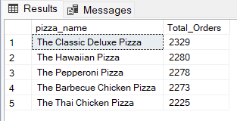
Bottom 5 Pizzas by Total Orders:
SELECT Top 5 pizza_name, COUNT(DISTINCT order_id) AS Total_Orders
FROM pizza_sales
GROUP BY pizza_name
ORDER BY Total_Orders ASC

